USAID/ACCELERATING SUPPORT TO ADVANCED LOCAL PARTNERS II
STRATEGIC INFORMATION WEBINAR SERIES

GIS Training

Use of GIS to analyze data and communicate results using maps

Dr. Dorman Chimhamhiwa and Victor Bangamwabo
GIS and Planning
Right to Care (Group)
April 2023

Outline

- Brief introduction to GIS
  - Data description, sources, and creation

- Practical application of GIS 1 – digital and hardcopy map output
  - Mapping and analyzing potential spatial patterns of HIV risk, based on study findings in a specific scenario

- Practical application of GIS 2 – analysis and map output as interactive online based resources
  - Application of GIS to support guide spatial targeting and micro-planning for field vaccination teams

GIS: Geographic Information Systems

- Brief overview of GIS – example of APACE date used for mapping
fundamentals

- Data description, sources, and creation:
    - Data types – representation
      - Spatial – points, polylines, and polygons
      - Non-spatial – tables
    - Data -- preparation, manipulation, and presentation:
      - Understand and/or define problem statement – how important is location?
      - Understand the data needs:
        - Available data – explore the data (GIS software, Excel, etc.)
        - Missing data -- that can be sourced, created, or derived from existing data.
      - Resources needed:
        - Software – desktop, online based, open-source vs proprietary

- Use of Open-Source GIS software (QGIS) to create a simple map layout:
    - https://qgis.org/
    - https://qgis.org/en/site/forusers/download.html

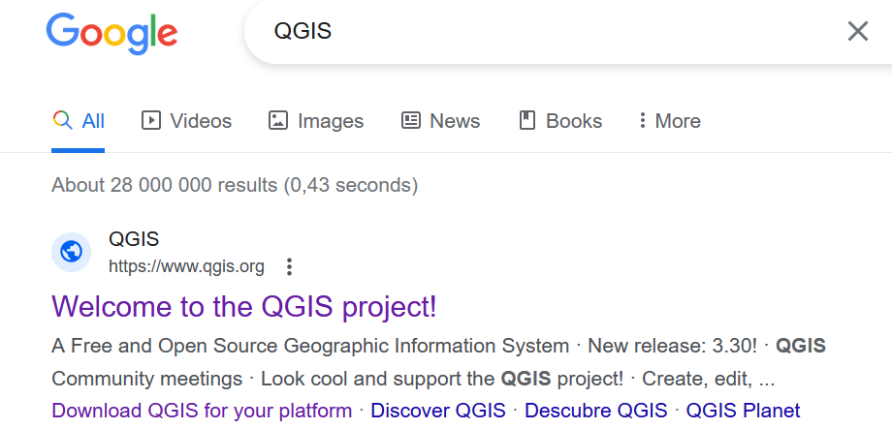
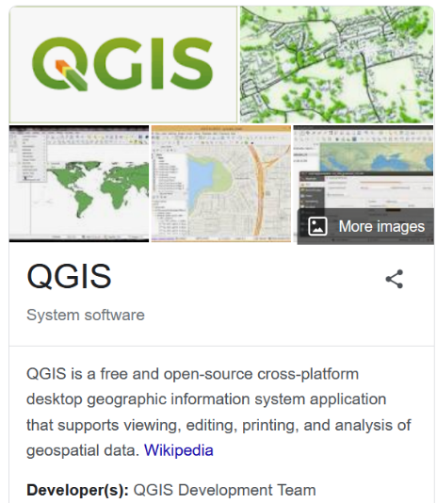

- Practical application of GIS 1 – digital and hardcopy map output
Case study - Mapping and analyzing potential spatial patterns of HIV risks, based on study findings in a specific scenario

Background
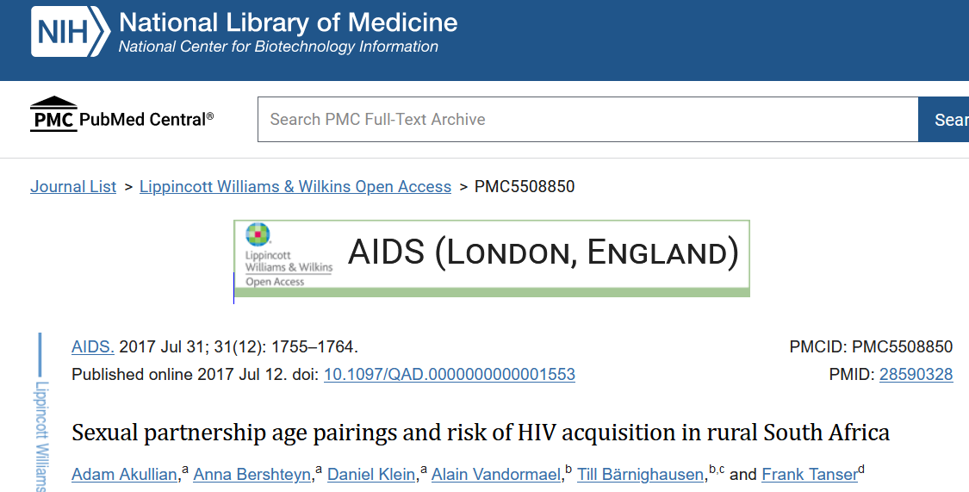
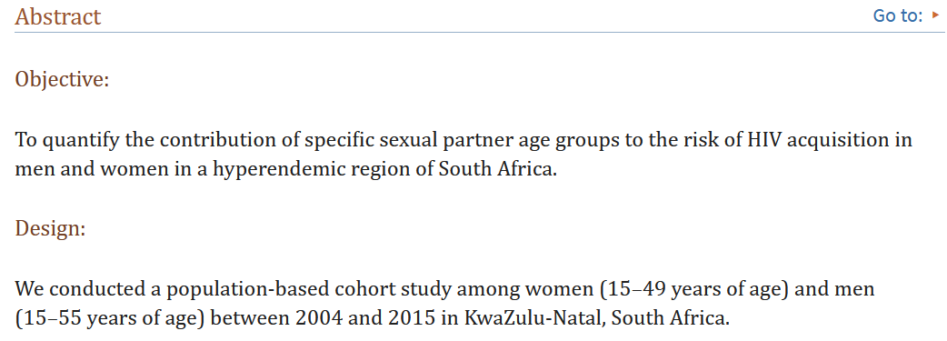
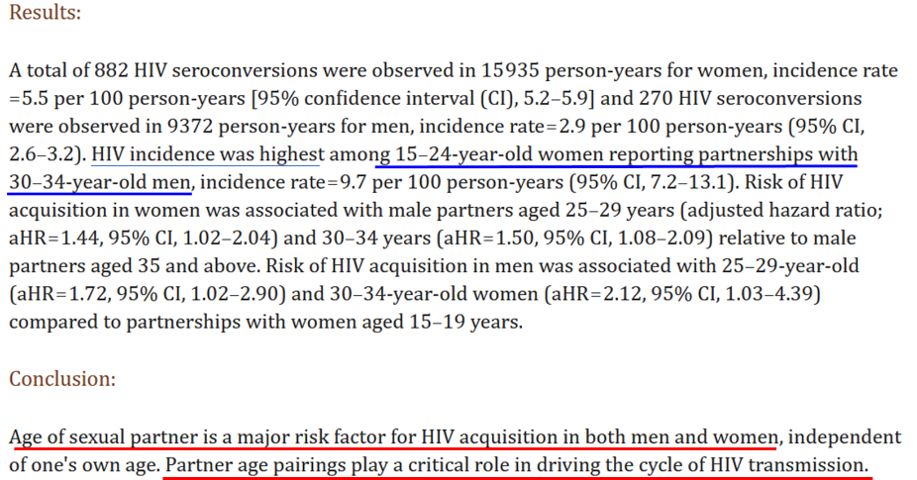
Aim: Explore and analyze spatial patterns of HIV-incidence from the findings shown above (for women 15-24 and men 30-34 years old) within eThekwini Metro, KwaZulu-Natal, South Africa.

Data:
- Settlement boundaries - Age, gender, and location attributes (population estimates broken down to granular census Enumeration Areas (EA))
- Health facilities
- Additional data:
  - District and sub-district boundaries
- Understand the data:
  - Explore the table for EAs (settlements data)
  - Explore Health Facility data.
  - Explore sub-district and metro data.

- How can we best represent this data spatially in the context of the aim outlined above? Can we identify rural areas from sample data of eThekwini Metro?

- Population size mapping:

  - General data symbolization - Where are the largest populations for all and both cohorts? We can explore two types of data symbology in a GIS software:
        - Graduated colors,
        - Proportional symbols
  - Age cohorts using Bivariate Symbology – GIS data symbology that allows comparison of two separate data fields.

- Where are the facilities that serve the population? – Add facilities data to the map.

- How far are the facilities? – advanced analysis.
  - Follow-up question that can be answered:
    - Where can we place testing points?

- What areas can we say are problematic?
  - For age groups (and gender)?
  - Type of intervention?

- Create printable maps that highlight the points in Number 5 above.
  - Add additional supporting data for more context.

C. Practical application of GIS 2 – analysis and map output as interactive online-based resources
Demonstration - COVID-19 Vaccine Coverage GIS Dashboards

Background
Spatialize the COVID-19 vaccination data to guide spatial targeting and micro-planning for field teams.
- Understand the data that would support this analysis:
  - Population estimates for eligible population (12+ years of age)
    - Provincial, district, sub-district, and settlement
  - Vaccination date recorded at province, district, sub-district, and settlement.
  - Data sources: Vaccination – National Department of Health (South Africa),
Population Estimates - StatsSA mid-year estimates and census (+ GTI estimates)
- Demo:
  - Explore data.
  - Create a map (export a static map) and develop a dashboard.
  - Demonstrate a complete dashboard (vaccine coverage dashboard).

Key takeaways for successful use of GIS to communicate results using maps:

- Definition of the problem, understanding the GIS data is required
- Data preparation, mapping, analysis, and visualization
- Preparation of end user output: creating maps and/or publishing online products (interactive maps and dashboards)

